DATABASE SCHEMA

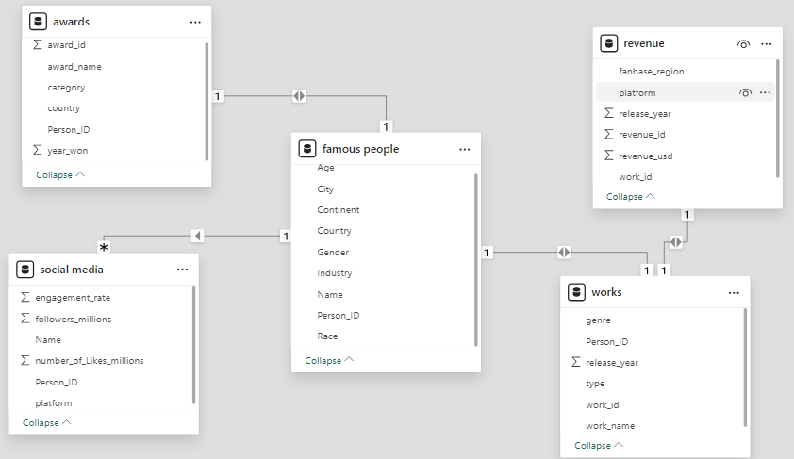

DATABASE TABLES

1. Table: famous people

**Columns: Data Type:**

|  |  |  |
| --- | --- | --- |
| **Person_ID** |  | **int AI PK** |
| **Name** |  | **varchar(100)** |
| **Age** |  | **int** |
| **Gender** |  | **varchar(10)** |
| **Industry** |  | **varchar(50)** |
| **City** |  | **varchar(100)** |
| **Country** |  | **varchar(100)** |
| **Race** |  | **varchar(50)** |
| **Continent** |  | **varchar(50)** |

1. Table: works

**Columns: Data Type:**

|  |  |
| --- | --- |
| **work_id** | **int AI PK** |
| **work_name** | **varchar(255)** |
| **Type** | **varchar(50)** |
| **Person_ID** | **int** |
| **release_year** | **int** |
| **Genre** | **varchar(255)** |

1. Table: awards

**Columns: Data Type:**

|  |  |
| --- | --- |
| **award_id** | **int AI PK** |
| **award_name** | **varchar(255)** |
| **Person_ID** | **int** |
| **category** | **varchar(255)** |
| **year_won** | **int** |
| **country** | **varchar(100)** |

1. Table: revenue

**Columns: Data Type:**

|  |  |
| --- | --- |
| **revenue_id** | **int AI PK** |
| **revenue_usd** | **bigint** |
| **release_year** | **int** |
| **platform** | **varchar(255)** |
| **work_id** | **int** |
| **fanbase_region** | **varchar(255)** |

1. Table: social media

**Columns: Data Type:**

|  |  |
| --- | --- |
| **Person_ID** | **int** |
| **Name** | **varchar(100)** |
| **platform** | **varchar(50)** |
| **followers_millions** | **decimal(10,2)** |
| **engagement_rate** | **varchar(10)** |
| **number_of_Likes_millions** | **decimal(10,2)** |